1. What is a Monolithic Application?
A monolithic application is built as one big, single unit.[Entire application written with same code, auto scaling is not ideally]
All features—login, orders, payments, notifications—live in the same codebase and are deployed together.
What are Microservices?
A microservices application is built as a collection of small, independent services.
Each service handles one function—like login, payment, cart, search—and they communicate over APIs.
Cloud native microservice?
Using multicloud expertise for application.
What is CNCF (Cloud Native Computing Foundation)?
Cloud-Native[in simple terms devops with multicloud integration] vs cloud based:
Cloud-native apps are designed for the cloud from the start.
They use microservices, containers, automation, and declarative APIs, and run in dynamic public/private/hybrid clouds.
They are scalable, resilient, and loosely coupled. [dev.to]
Cloud-based apps are traditional applications simply hosted on the cloud, instead of your own servers.
They might still be monolithic, tightly coupled, hard to scale, and not built using cloud-native patterns.
Cloud Native application development principles:
Link: https://cloud.google.com/blog/products/application-development/5-principles-for-cloud-native-architecture-what-it-is-and-how-to-master-it
Principle | Story Meaning | What It Means Technically
1. Design for automation | Let systems run themselves | Automate deployments, scaling, recovery
2. Be smart with state | Keep memories in safe vaults | Minimize state, use reliable storage
3. Favor managed services | Use experts, not DIY | Use cloud-managed databases, queues, auth
4. Defense in depth | Every house has its own shield | Zero-trust, validation, rate limiting, isolation
5. Always be architecting | City keeps evolving | Continuously refine architecture as cloud evolves

The Cloud Native Computing Foundation (CNCF) is a nonprofit, vendor-neutral foundation under the Linux Foundation that supports and governs major cloud-native open-source projects such as Kubernetes, Prometheus, Envoy, and Helm.
It exists to promote cloud-native technologies and make modern, scalable software possible across any cloud. [phoenixnap.com]
CNCF provides:
- A neutral home for open-source projects
- Community governance
- Standards and best practices
- Training and certifications (like CKA & CKAD)
- Community events like KubeCon + CloudNativeCon
Its job is to build a sustainable ecosystem for cloud-native development. [phoenixnap.com]
How CNCF Earns Money (Revenue Model)
Although CNCF is a nonprofit, it still requires income to operate, run events, support projects, and grow its ecosystem. CNCF earns money mainly from four revenue streams:
1. Membership Fees (Major Source)
CNCF has nearly 800 member companies (including Google, Microsoft, Amazon, startups, and end users).
Membership tiers include Platinum, Gold, Silver, and End-User memberships. [cncf.io]
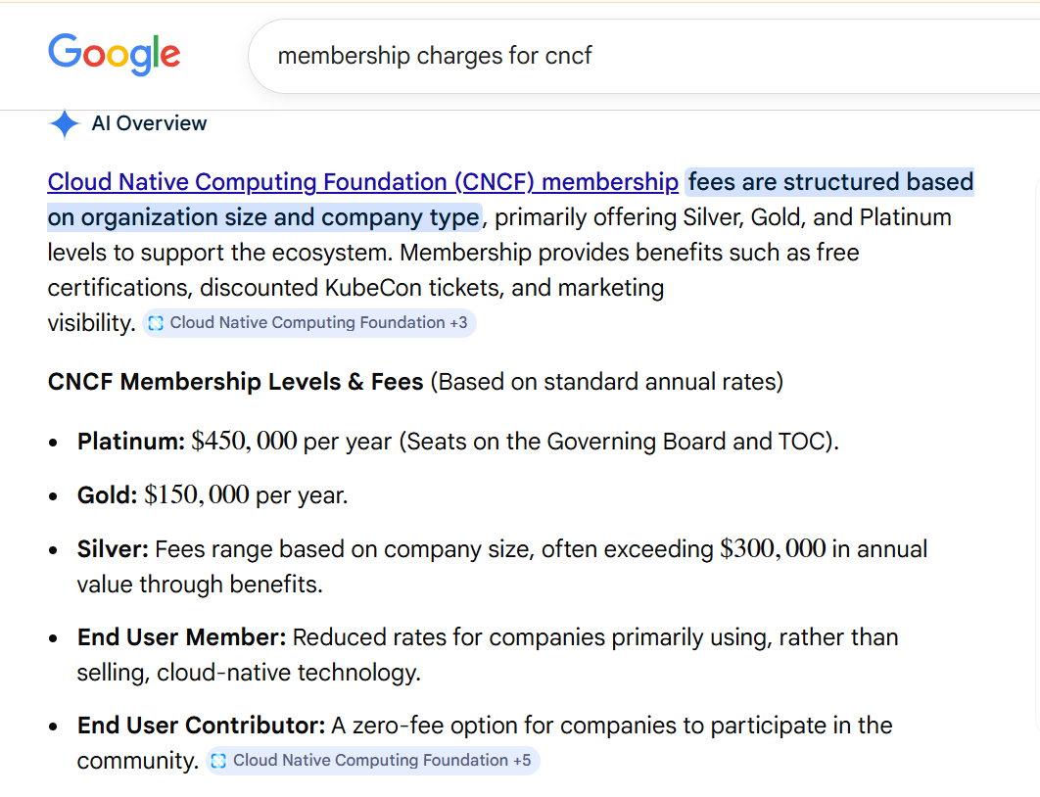
Members pay annual fees to:
- Support CNCF projects
- Vote in governance decisions
- Access marketing/exposure opportunities
- Join working groups/SIGs
- Help influence cloud-native standards
Membership is one of CNCF’s largest and most stable revenue sources.
2. Event Sponsorships & Conferences
CNCF runs massive global events such as KubeCon + CloudNativeCon.
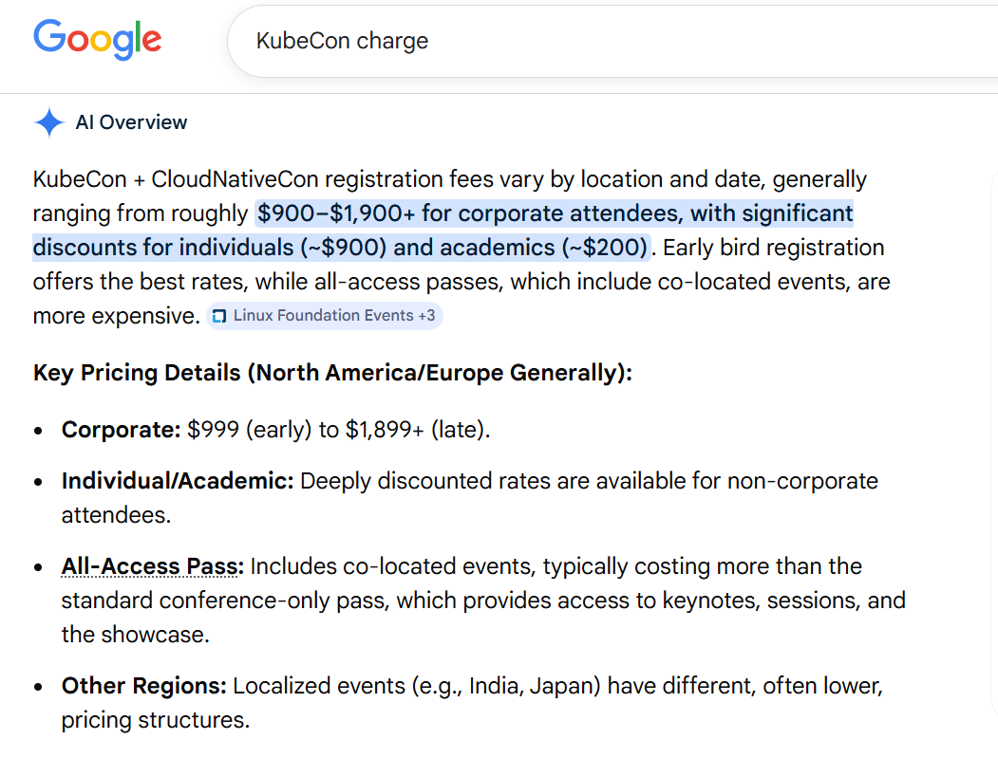
Companies sponsor these events for branding, booths, and visibility.
The Linux Foundation provides detailed sponsorship prospectuses highlighting benefits for companies. [events.lin...dation.org]
Event revenue comes from:
- Corporate sponsorship packages
- Exhibitor booths
- Paid passes for attendees
- Co-located event sponsorships
These events often sell out, contributing significant revenue.
3. Training & Certification Programs
CNCF offers cloud-native certifications such as:
- CKA (Certified Kubernetes Administrator)
- CKAD (Kubernetes Application Developer)
- CKS (Kubernetes Security Specialist)
- KCNA, PCA, ICA, etc.
These exams and their training programs are major revenue sources.
The foundation’s education programs are highlighted as one of its key offerings. [phoenixnap.com]
4. Donations & Funding Sources
The CNCF Annual Report includes a section on Funding, which outlines that the foundation receives financial contributions to support its open-source initiatives. [cncf.io]
This funding comes from:
- Member company donations
- Supporting foundations (Linux Foundation)
- Special grants for open-source research and development
Summary: How CNCF Makes Money
Revenue Source | How Money Comes In | Evidence
Membership Fees | Companies pay annual fees to join CNCF | [cncf.io]
Event Sponsorships & Tickets | Companies sponsor KubeCon, booths, event tickets | [events.lin...dation.org]
Certifications & Training | CKA, CKAD, CKS, and training courses | [phoenixnap.com]
Donations / Funding Programs | Community donations, grants, Linux Foundation support | [cncf.io]

how multi‑vendor development works in CNCF projects — and whether AWS can “share” something with Google for GKE?
They do not “share secrets”, but they do share code, designs, proposals, and standards through open-governance, public repos, vendor-neutral rules, and community processes.
This collaboration is by design: CNCF’s governance enforces vendor neutrality, open contribution, and transparent decision-making.
Why Google donated k8s to CNCF when he can manage it, help me to understand it?
Ecosystem components — CNI[Container Network Interface], CSI[Container Storage Interface], autoscaling engines, monitoring, CRI runtimes — required contributions from hundreds of companies.
For example:
- etcd (core datastore) maintained by multiple vendors
- CNI plugins from AWS, Calico, Cilium
- CSI drivers from every storage vendor
- Cluster API from multiple cloud providers
By moving Kubernetes to CNCF, Google enabled parallel technical innovation across the global cloud industry.
This collaborative, multi-vendor development model is described as essential for cloud-native ecosystem growth.

